INNOVATIVE PRACTICES REPORT

**Silent Speech Recognition using EEG Signals**

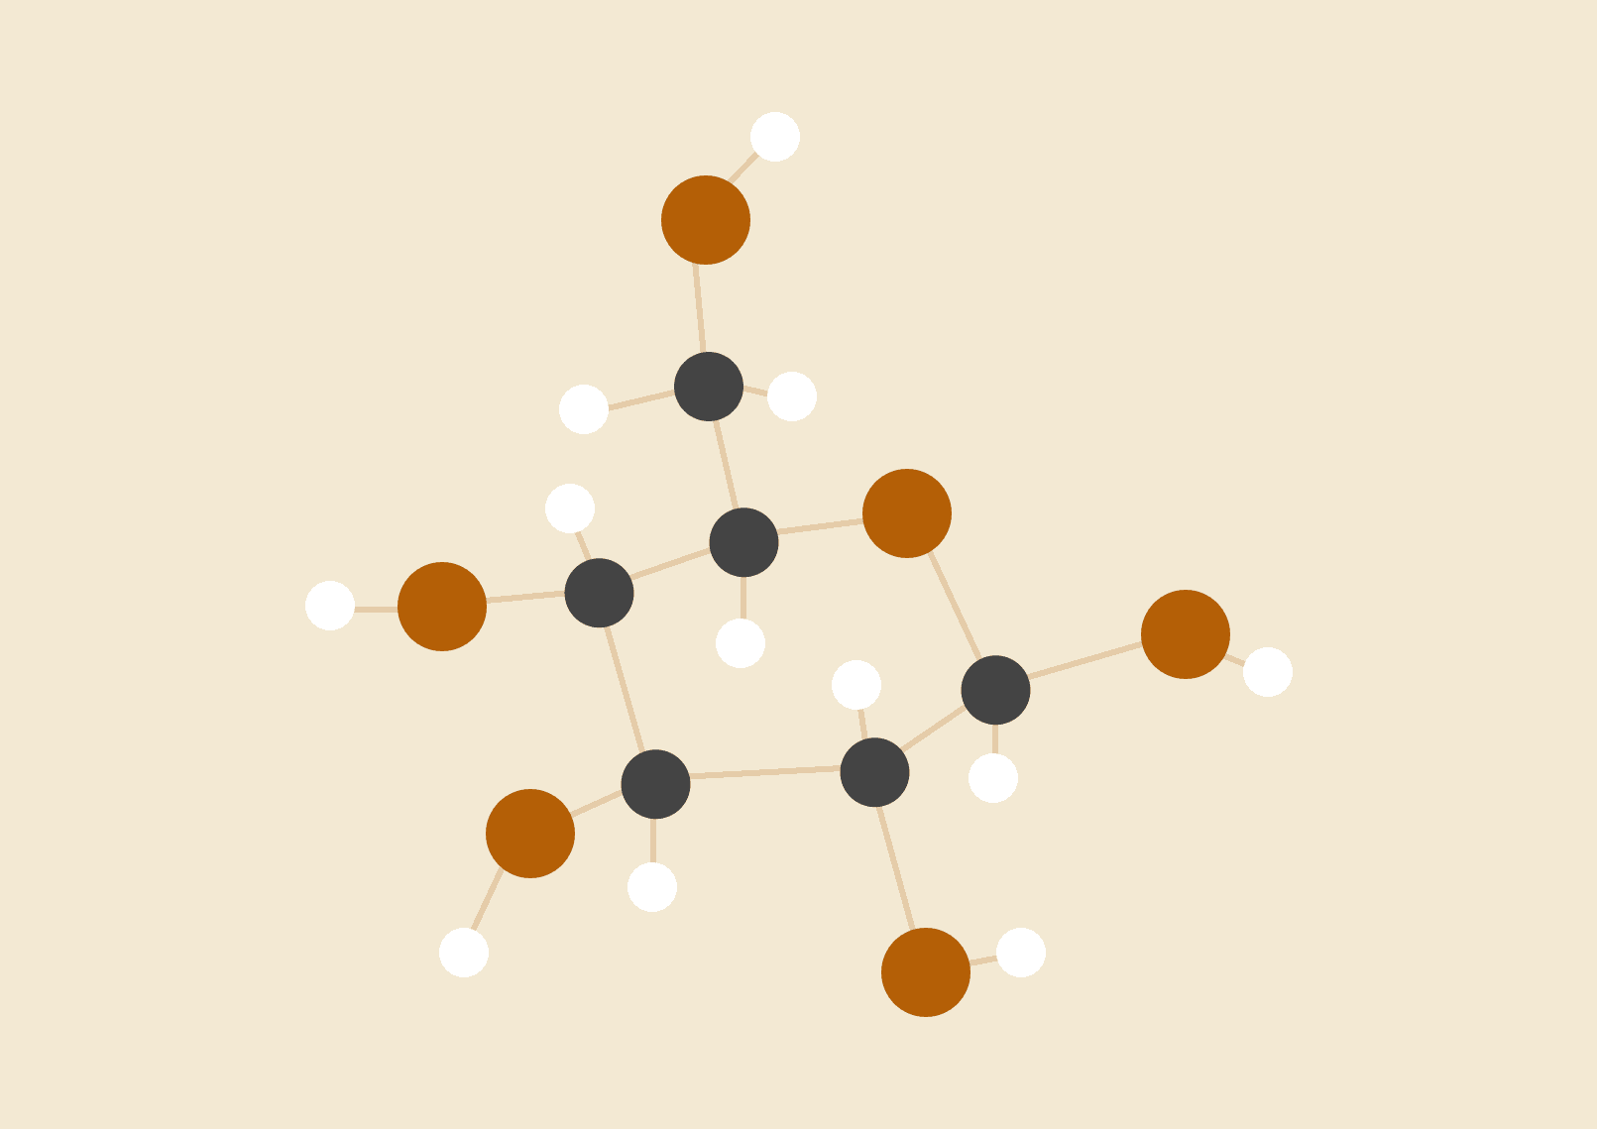

**AJAY GOWTHAM S**

**TABLE OF CONTENTS PAGE**

**ACKNOWLEDGEMENT……………………………………………………………………….3**

**1. INTRODUCTION………………………………………………………………………..........6**

**2.LITERATURE SURVEY ……………………………………………………………….…... 10**

**3. COMPONENT DETAILS……………………………………………………………………18**

**4. SYSTEM REQUIREMENTS………………………….…………………………………..…19**

**5. SYSTEM ANALYSIS AND DESIGN……………………………………….……………….20**

**6.SOFTWARE SIMULATION….………………………………………………………………21**

**7. HARDWARE DESIGN ……..………………………………………………………………..24**

**8. CONCLUSION AND FUTURE WORK…………………..………………………………..26**

**9. REFERENCES…………………………………………….…………………………………27**

**10. TIMELINE CHART:.............................................................................................................................29**

**ACKNOWLEDGEMENT**

I would like to extend my sincere thanks to Dr. K. Prakasan, Principal, PSG College of Technology, for providing us with a wonderful opportunity to develop and complete a project in my field of study.

I profoundly thank Dr.G. Sudha Sadhasivam,, Professor and Head, Department of Computer Science and Engineering, who has greatly helped in the success of the project by providing the necessary facilities that were required.

I take immense pleasure in conveying my thanks and deep sense of gratitude to the program coordinator Dr.V.Santhi Associate Professor, Department of Computer Science and Engineering, for her valuable suggestions and motivation all through the course of the project.I would like to express my deepest gratitude to our project guide Dr. G. Sudha Sadhasivam, Head of Department, Department of Computer Science and Engineering, for the exemplary guidance, timely advice, valuable directions, constant support, and encouragement given in completing my project work.

I express my thanks and gratitude to my tutor Mrs.S.Arul Jothi , Assistant Professor (SG), Department of Computer Science and Engineering, for help and encouragement during the course duration.

I express my sincere thanks to all the panel members and faculty in charge and research scholar Vaishanavi K for helping me in resolving the problems that occurred during the project work.

**SYNOPSIS:**

**Silent speech recognition using EEG signals**

**Abstract**

Silent speech recognition has emerged as a promising technology for assisting individuals with speech impairments. The major objective is to detect silent speech recognition systems tailored for older adults using electroencephalography (EEG) signals. The aim is to provide an alternative communication method for elderly individuals who may have difficulty producing audible speech due to age-related factors or conditions such as stroke or neurodegenerative diseases.

The proposed system utilizes EEG signals, which are non-invasive and can be captured through electrodes placed on the scalp. The recorded EEG signals are processed using advanced signal processing techniques to extract relevant features related to silent speech production. Machine learning algorithms, such as deep neural networks, are then employed to train a recognition model capable of translating these EEG features into recognizable speech patterns.

To develop an effective silent speech recognition system, several challenges need to be addressed, including the identification and extraction of informative EEG features, handling individual differences in brain activity, and optimizing the recognition accuracy and response time. Additionally, considerations for real-time implementation and user-friendly interfaces tailored to the needs and abilities of older adults are crucial for practical application.

This project aims to investigate and develop techniques for silent speech recognition using EEG signals, specifically targeting the older adult population. The ultimate goal is to design an intuitive and efficient system that can assist older individuals in expressing themselves and communicating effectively despite speech impairments. Successful implementation of this technology has the potential to significantly improve the quality of life for elderly individuals, enabling them to engage in social interactions and maintain their independence.We have completed a circuit that detects that brain signal of 40Hz and converts that signal to csv file using Arduino.

**CHAPTER 1**

**Introduction**

Individuals with severe disabilities often face challenges in verbal communication, limiting their ability to express themselves and interact with others effectively. Augmentative and Alternative Communication (AAC) systems have emerged as valuable tools to assist individuals with communication impairments. However, traditional AAC systems may not cater to the diverse needs and capabilities of each user, leading to limitations in their overall efficacy and user experience. The primary objective of our project is to design and develop a cutting-edge communication tool that adapts to the unique abilities of each user, fostering personalized and efficient communication experiences.

**Imagined Speech:**

Imagined speech, also known as covert speech or inner speech, refers to the process of mentally producing and perceiving speech without any actual vocalization. It involves simulating the experience of speaking in one's mind, often accompanied by the sensation of hearing the spoken words internally. Imagined speech is a fundamental aspect of human cognition and plays a crucial role in various cognitive functions, language processing, and self-regulation. Imagined speech is a complex cognitive phenomenon that involves the mental generation and perception of speech without actual vocalization. It plays a significant role in language processing, self-regulation, and various cognitive processes, enhancing the ability to think, plan, and communicate effectively.

**Application of Imagined Speech:**

Imagined speech, or covert speech, has several practical applications across various fields due to its role in cognition, communication, and brain activity. Here are some notable applications of imagined speech:

**1. Neurorehabilitation:**

Imagined speech can be used in neurorehabilitation programs for individuals with speech-related disorders, such as aphasia, apraxia, or stuttering. By engaging in imagined speech exercises, individuals can practice and enhance their speech motor planning and coordination, which can help improve their actual speech production.

**2. Assistive Communication:**

For individuals with severe speech disabilities who cannot communicate verbally, imagined speech can be harnessed for developing assistive communication technologies. Brain-computer interfaces (BCIs) can translate imagined speech into text or synthesized speech, allowing non-verbal individuals to communicate using their thoughts.

**3. Speech Training:**

Imagined speech can be used in speech training and public speaking coaching. Individuals can mentally rehearse their speeches, presentations, or performances, helping them become more confident and articulate when delivering them in real life.

**4. Cognitive Therapy:**

In cognitive-behavioral therapy and cognitive restructuring, imagined speech can help individuals challenge negative thought patterns and self-talk. It allows them to reframe negative thoughts into more positive and constructive ones, leading to improved emotional well-being.

**5. Language Learning:**

When learning a new language, imagined speech can aid in language comprehension and acquisition. Learners can practice forming sentences and engaging in conversations mentally, which can help reinforce vocabulary and grammar rules.

**6. Memory Enhancement:**

Imagined speech has been used as a mnemonic technique to enhance memory. By internally vocalizing information to be remembered, individuals can create stronger memory traces, making it easier to recall information later.

**7. Thought Organization:**

Imagined speech helps individuals organize their thoughts and ideas. When faced with complex problems or decisions, engaging in internal dialogue can help clarify thoughts and evaluate different options.

**8. Cognitive Neuroscience Research:**

Researchers use imagined speech to investigate neural processes associated with language comprehension, production, and other cognitive functions. Brain imaging techniques like functional MRI (fMRI) and EEG are used to study brain activity patterns during imagined speech tasks.

**9. Brain-Computer Interfaces (BCIs):**

BCIs that rely on imagined speech are being developed to provide communication channels for individuals with locked-in syndrome or other conditions that impair verbal communication. These interfaces convert imagined speech patterns into meaningful commands or text.

**10. Lie Detection and Deception Studies:**

Imagined speech can play a role in studies related to deception and lie detection. Researchers investigate brain activity patterns associated with truthful versus fabricated statements during imagined speech tasks.

**11. Human-Computer Interaction (HCI):**

In HCI research, imagined speech could potentially be used as a command input for devices and applications, expanding the ways humans interact with technology.

**12. Neuroscience Education:**

Imagined speech is often used in educational settings to illustrate concepts related to cognition, language processing, and brain activity patterns. It provides a practical example of how the mind generates and processes speech internally.

**Augmentative and Alternative Communication**

"Augmentative and Alternative Communication" (AAC) refers to a set of methods, strategies, and tools that are used to supplement or replace spoken communication for individuals who have difficulty with speech or cannot rely on speech alone to communicate effectively. AAC encompasses a wide range of techniques, from simple gestures and facial expressions to sophisticated electronic devices and computer-based systems.

AAC is used by individuals with various conditions that affect their ability to communicate verbally, such as:

**1. Speech Disorders**: People with conditions like apraxia, dysarthria, or stuttering may have difficulty forming words or speaking fluently.

**2. Language Disorders:** Individuals with conditions such as aphasia or developmental language disorders may struggle to understand or use language effectively.

**3. Neurological Conditions:** Some neurological conditions like cerebral palsy, ALS (amyotrophic lateral sclerosis), or traumatic brain injuries can lead to severe speech and communication difficulties.

**4. Degenerative Diseases:** Conditions like Parkinson's disease or certain types of dementia can progressively impact speech and communication abilities.

**5. Congenital Conditions**: Some individuals are born with conditions that affect speech and language development, such as Down syndrome.

AAC methods can be categorized into two main types:

**1. Augmentative Communication**: This involves using tools and strategies to supplement an individual's existing communication abilities. For example, a person with limited speech might use gestures, communication boards with pictures or symbols, or electronic devices with pre-recorded messages to express themselves more effectively.

**2. Alternative Communication:** In cases where spoken communication is not possible or not reliable, alternative communication methods are used. This can include using communication devices that generate synthesized speech based on the user's input. These devices may be controlled through switches, eye gaze, head movement, or other alternative means.

AAC solutions can range from low-tech to high-tech and are chosen based on the individual's needs, abilities, and preferences. Some common AAC tools and strategies include:

- Communication Boards: These are physical or digital boards with pictures, symbols, or words that the individual can point to or select to communicate.

- Speech-generating Devices: These are electronic devices that generate speech based on user input, which can be selected through buttons, touchscreens, or other input methods.

- Symbol Systems: Systems like PECS (Picture Exchange Communication System) use pictures or symbols to represent words, phrases, or concepts.

- Text-to-Speech Apps: These apps allow users to type or select text, which is then converted into synthesized speech.

- Eye Gaze Technology: For individuals with limited motor control, eye gaze technology tracks their eye movements to select symbols or words on a screen.

The main goal of AAC is to provide individuals with effective means of communication, enhance their participation in social interactions, and improve their overall quality of life. The choice of AAC methods depends on factors such as the individual's cognitive abilities, motor skills, communication goals, and personal preferences.

**CHAPTER 2**

**LITERATURE SURVEY**

**Review of Literature**

Shunan Zhao and Frank Rudzicz [1] effectively present a comprehensive and well-organized study, beginning with a clear introduction that sets the context and motivation for the research. The significance of understanding imagined speech, along with its potential applications in fields like neuro-rehabilitation and brain-computer interfaces, is aptly conveyed and the experimental design and methodology are robust, which adds to the credibility of the study. The authors employed a well-balanced approach by collecting both imagined and actual speech data from a considerable number of participants. The usage of EEG (electroencephalography) to record brain activity during the tasks is appropriate for the research question at hand.

S. Datta and N. V. Boulgouris [2] effectively lay the groundwork for their research with a well-structured introduction, providing a clear motivation for their study and its potential implications. The relevance of combining EEG-based brain activity analysis with NLP to understand cognitive processes involved in language comprehension is well-articulated.

M. A. Bakhshali et. al [3] effectively highlights the potential applications of research, ranging from communication aids for individuals with speech disabilities to advancements in neuroscience understanding. The experimental design and methodology are well-structured and thorough. The use of Riemannian distance and cross entropy spectral density as novel features for EEG signal classification is innovative, and the authors provide a compelling rationale for their choice of techniques. The study's inclusion of a diverse set of participants who performed imagined speech tasks enriches the validity and generalizability of the findings.

Mohanchandra et. al [4] effectively highlights the significance of subvocalized speech as an underlying neural process for speech generation, laying a strong foundation for their communication paradigm. The experimental design and methodology are well-structured and methodically presented. The study's focus on subvocalized speech, a covert form of speech production, adds novelty and potential value to the field of BCIs. The inclusion of participants with various abilities and communication needs enhances the study's relevance and real-world applicability. The paper's detailed description of the data acquisition and processing techniques demonstrates the researchers' diligence in handling brain signals. The use of machine learning algorithms to decode brain signals and convert them into recognizable speech further validates the feasibility and practicality of the communication paradigm.

P. Saha et al [5] delve into the intersection of neuroscience and deep learning, showcasing the potential of machine learning algorithms in decoding brain activity related to phonological processing. The introduction provides a clear and compelling rationale for the research, emphasizing the significance of phonological categorization in language processing and its potential applications in various domains, including communication technology and neurorehabilitation. The experimental design and methodology are rigorously presented, showcasing the authors' expertise in handling EEG data and deep learning algorithms.

Sharon, Rini A. and Hema A. Murthy [6] investigates the potential applications of their research in augmentative and alternative communication (AAC) systems and the broader field of assistive technology. The experimental design and methodology are well-structured, showcasing the researchers' expertise in EEG signal processing and feature extraction. The use of correlation-based multi-phasal models is innovative, as it takes into account the complex and dynamic nature of EEG signals during imagined speech tasks.

R. A. Sharon et. al [7] investigates the neural processes underlying speech decoding across different cognitive states: audition, imagination, and production. The study delves into the fascinating field of neural speech processing, contributing valuable insights into the distinct brain mechanisms associated with these speech-related tasks. The authors effectively highlight the novelty of examining speech processing during imagination, a less explored cognitive state. The experimental design and methodology are comprehensive, showcasing the researchers' expertise in neural signal analysis and cognitive neuroscience. The use of EEG data to investigate neural speech processing in real-time during different cognitive tasks adds a unique dimension to the study.

Rusnac et. al [8] effectively highlight the potential applications of their work, ranging from communication aids for individuals with speech impairments to advancements in neural engineering and neuroprosthetics. The experimental design and methodology are well-structured, showcasing the researchers' expertise in both EEG signal analysis and deep learning techniques. The use of CNN-LSTM as a hybrid model is innovative, as it takes advantage of the strengths of both convolutional networks and long-short term memory units for processing sequential EEG data.

V. Varshney and A. Khan [9] effectively set the context by emphasizing the potential applications of their work in assistive communication technologies and neural engineering. The experimental design and methodology are meticulously presented, demonstrating the researchers' expertise in both signal processing and speech classification. The use of a set of phonetically distributed words for imagined speech tasks adds novelty to the study, as it allows for comprehensive exploration of the brain's response during different linguistic processes.

S. Ling et. al [10] effectively contextualize their work by highlighting the potential applications of their findings in advancing our understanding of how language is processed in the brain. The study's experimental design and methodology are meticulously presented, showcasing the researchers' expertise in EEG-based brain decoding and image reconstruction techniques. By using EEG data for visual word decoding, the study introduces a novel approach to exploring the neural correlates of language-related processes, adding a valuable dimension to the existing literature on language representation. The study presents an innovative approach to inferring imagined speech from EEG signals, introducing the use of Riemannian manifold features for decoding cognitive processes related to speech.

C. H. Nguyen et. al [11] effectively sets the context for the research, highlighting the significance of decoding imagined speech for neuro rehabilitation and assistive communication technologies. The authors' emphasis on the potential applications of their work adds value to the paper, as it showcases the practical relevance of their findings.

The study explores a novel approach to decoding imagined speech by utilizing wavelet features and deep neural networks (DNNs). The introduction effectively sets the context for the research, highlighting the significance of decoding imagined speech for brain-computer interfaces and assistive communication technologies. J. T. Panachakel et al. [12] provide a clear rationale for using wavelet features and DNNs, adding value to the paper by showcasing the practical applications of their findings.

The paper's detailed description of the data preprocessing and feature extraction methods provides a comprehensive understanding of the technical aspects of the study. The inclusion of a diverse dataset and statistical analysis enhances the study's credibility, making it a reliable reference for researchers in the field. S. Mandala et al. [13] could explore the limitations or challenges associated with the use of wavelet features and DNNs in EEG signal analysis. Discussing these aspects would provide researchers with a more comprehensive understanding of the method's strengths and weaknesses.

The introduction effectively contextualizes the study by highlighting the importance of EEG signal analysis for recognizing imagined vowels. L. C. Sarmiento et. al [14] outline the relevance of their work in the development of assistive communication technologies and brain-computer interfaces, enhancing the paper's practical implications.

The paper provides a comprehensive explanation of the data collection and feature extraction process, enabling readers to understand the technical aspects of the study. The inclusion of detailed experiments and statistical analysis enhances the study's credibility, making it a valuable resource for researchers in the field. A.-L. Rusnac and O. Grigore [15] analysis offers valuable insights into the performance of CNN architectures and feature extraction methods for EEG-based imaginary speech recognition. The reported accuracy metrics indicate the effectiveness of the proposed approach in distinguishing different imaginary speech patterns from EEG signals.

Muse is well-known for its EEG headbands that allow users to monitor their brain activity and engage in meditation and mindfulness practices. With real-time feedback provided through its accompanying app, users can enhance their focus and relaxation levels.

NeuroSky specializes in biosensor technology, particularly EEG and electrooculography (EOG) sensors, which are integrated into various consumer electronics and medical devices. Their technology enables brainwave monitoring and interpretation, facilitating applications ranging from gaming to mental health diagnostics.

BrainTap offers a range of audiovisual entertainment devices designed to optimize brain function, reduce stress, and enhance overall well-being. By combining guided meditation, neuroacoustic soundscapes, and synchronized light therapy, BrainTap aims to induce deep relaxation and mental clarity.

FocusCalm is another player in the neurofeedback market, providing a wearable EEG headband and accompanying app designed to help users improve their focus and concentration. Through real-time monitoring of brainwave patterns, users receive feedback and training exercises to enhance cognitive performance.

Mendi focuses on brain training and rehabilitation through its neurofeedback device, which utilizes functional near-infrared spectroscopy (fNIRS) to measure brain activity. Targeted at athletes, Mendi's system aims to optimize cognitive performance and aid in recovery from brain injuries through personalized training programs and data-driven insights. These companies collectively represent the growing interest and investment in leveraging neurotechnology for personal development, mental health, and performance enhancement.

**Inferences:**

In this thorough literature survey, they highlight the significance of decoding imagined speech for diverse applications, including neuro-rehabilitation, brain-computer interfaces, and assistive communication technologies. The featured papers collectively underscore the innovative use of EEG data to uncover the neural underpinnings of speech-related cognitive processes. By employing robust experimental designs and methodologies, these works contribute to the credibility and advancement of the field. The authors consistently emphasize the practical implications of their research, showcasing the potential for real-world impact. Notably, the integration of diverse participant groups, novel feature extraction techniques, and machine learning algorithms enhances the validity and generalizability of the findings. Overall, this survey underscores the progress made in decoding silent speech using EEG signals and highlights avenues for future research, while also underscoring the critical role of EEG data analysis in advancing our understanding of language processing and its neural mechanisms. Based on the literature survey we can consider the electrode positions TP9, TP10, FP1 and FP2 for silent speech analysis because these positions are responsible for silent speech.

**Imagined Speech:**

The studies in this category underscore the significance of understanding imagined speech and its potential applications. Researchers employ EEG to record brain activity during tasks related to speech imagination, which is a crucial area of investigation for applications in neuro-rehabilitation and brain-computer interfaces. By collecting both imagined and actual speech data from a diverse set of participants, these studies provide robust methodologies that enhance the credibility of their findings. The inclusion of participants with varying abilities and communication needs underscores the real-world relevance of this research. Notably, these studies highlight the importance of EEG signal analysis for recognizing imagined vowels, paving the way for the development of assistive communication technologies and brain-computer interfaces.

**EEG Board Design:**

The literature review within this category centers on the design and implementation of EEG signal acquisition boards and related technology. These studies present innovative solutions to EEG signal acquisition, addressing issues like noise reduction, scaling, and real- time data transfer. The proposed designs offer low-cost, modular EEG acquisition systems that can be utilized in various applications, from entertainment and rehabilitation to scientific research. The importance of timing precision in EEG-based brain-computer interfaces is emphasized, along with practical considerations for enhancing measurement performance. These studies have practical implications in the development of efficient EEG acquisition systems for a range of applications, including brain-computer interfaces and neuroergonomics. Examples of EEG devices akin to Muse include Emotiv Insight, NeuroSky MindWave, BrainBit, OpenBCI, BrainLink Lite, and Versus Headset, each offering real-time monitoring and feedback on brainwave activity for applications such as meditation, cognitive training, and sleep tracking.

**Augmentative and Alternative Communication (AAC):**

The research in this category delves into the potential applications of EEG-based speech classification and silent speech recognition in assistive communication technologies. The studies offer innovative approaches to EEG signal processing, including the use of novel features like Riemannian distance and cross-entropy spectral density. The findings have far-reaching implications, from aiding individuals with speech disabilities to advancing our understanding of neural engineering and language representation in the brain. The emphasis on the practical applications of this research in augmentative and alternative communication systems demonstrate its relevance and potential to benefit individuals with speech impairments.

The research on silent speech analysis using EEG holds paramount importance in contemporary science and technology due to its multifaceted implications. Firstly, it addresses fundamental questions about the human brain's ability to process and decode silent speech, shedding light on the intricate neural mechanisms involved. This knowledge is not only vital for advancing our understanding of cognitive processes but also has transformative applications in the fields of neuro-rehabilitation, allowing individuals with speech disabilities to communicate effectively. Moreover, silent speech recognition using EEG has the potential to revolutionize brain-computer interfaces, offering a means for seamless interaction with technology through thoughts alone. Furthermore, this research extends its influence into the domain of augmentative and alternative communication (AAC), providing innovative solutions for those who rely on assistive communication devices. In an era where technology and neuroscience converge, the study of silent speech through EEG emerges as a crucial area of inquiry with the power to improve lives, enhance communication, and push the boundaries of human-computer interaction.

**CHAPTER 3**

**COMPONENT DETAILS**

**PCB**

1. Biokit Type-B1110913

**Integrated Circuit**

1. LM 324 qty 2(U3 & U4)
2. LM 7805 qty 1(U1)
3. LM 7905 qty 1(U2)

**LED**

1. 3mm qty 2(LD 1 & 2)

**Capacitor**

1. 100uf 16 Volt qty 4 (C1, C5, C4, C8)
2. Ruf 16 Volt qty 4 (C13, C14, C15, C16)
3. uf 16 Volt qty 2 (C19, C20)
4. 0. Iuf qty 8 (C2, C3, C6, C7, C17, C18, C21, C22)
5. 120pf qty 2 (C9, C10)
6. 330pf qty 2 (C11, C12)

**Resister**

1. 1k qty 2 (R1, R2)
2. 10k qty 2 (R4, R6)
3. 20k qty 1 (R7)
4. 1M qty 3 (R12, R13, R20)
5. 5.1k qty 2 (R23, R24)
6. 100k qty 12(R8, R9, R10, R11, R14, R15, R16, R17, R18, R19, R21, R22)
7. 47k qty 2 (R3, R5)

**CHAPTER 4**

**SYSTEM REQUIREMENTS**

**Hardware Requirements:**

* LM 324
* LM 7805
* LM 7905
* RESISTORS
* CAPACITORS
* ELECTRODES
* DUAL POWER SUPPLY BATTERY(12V)
* ARDUINO MICROCONTROLLER

**Software Requirements:**

* TINA SOFTWARE FOR SIMULATION
* ARDUINO IDE
* SERIAL PLOT

**CHAPTER 5**

**SYSTEM ANALYSIS AND DESIGN**

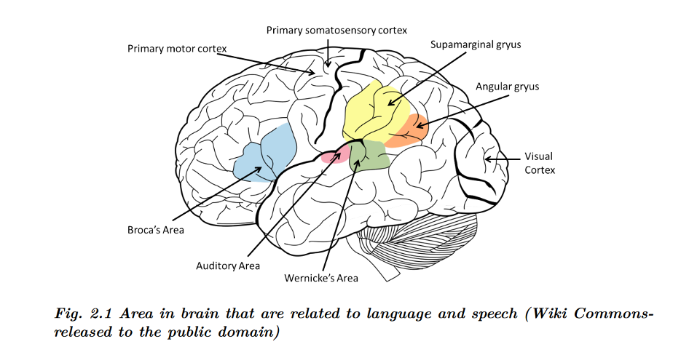

**Electrode Positions**

*Fig. 5.1 Area in brain that are related to language and speech*

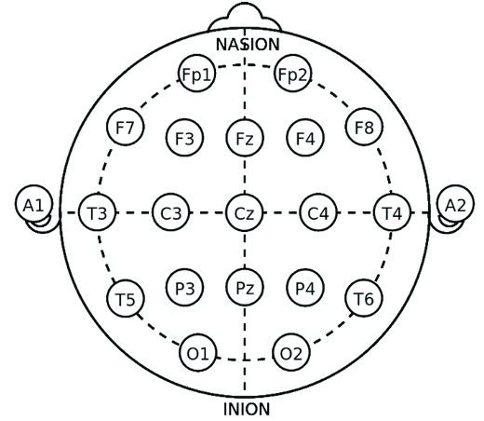

*Fig. 5.2 Standard Electrode Position 10-20 system for EEG*

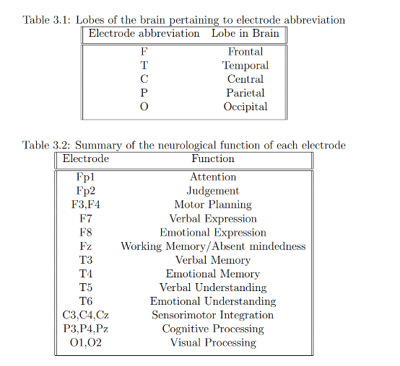

*Table 5.1: Lobes of the brain pertaining to electrode abbreviation*



*Table 5.2: Summary of the neurological function of each electrode*

**Abbreviations:**

1. ‘C4’: postcentral gyrus
2. ‘FC3’: premotor cortex
3. ‘FC1’: premotor cortex
4. ‘F5’: inferior frontal gyrus, Broca’s area
5. ‘C3’: postcentral gyrus
6. ‘F7’: Broca’s area
7. ‘FT7’: inferior temporal gyrus
8. ‘CZ’: postcentral gyrus
9. ‘P3’: superior parietal lobule
10. ‘T7’: middle temporal gyrus, secondary auditory cortex
11. ‘C5’: Wernicke’s area, primary auditory cortex

The EEG signals which are extracted with the help of dry electrodes is fed into a low pass filter of 40 Hz cut off frequency as the brain wave frequency ranges from 1 Hz to 40 Hz.Since the starting frequency range is 1 Hz, we are using a high pass filter of 1 Hz cut off frequency. The filtered signal is then fed to an amplifier of 8 Gain since our signal strength is too low. Then the denoised and filtered signal is sent to an ADC converter and the final output signal is sent to our mobile using Arduino microcontroller and a Bluetooth microcontroller.

**CHAPTER 6**

**SOFTWARE SIMULATION**

**i). Low Pass Filter Simulation:**

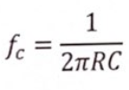The hardware simulation part was accomplished with the aid of Tina software. The low pass filter, high pass filter, notch filter, amplifier, and the complete circuit were simulated using Tina software. Since this system deals with brain waves, a low pass filter is designed for 40Hz. A low pass filter allows frequencies lower than the cutoff frequency and attenuates frequencies higher than the cutoff frequency. As the frequency is capped at 80Hz, the system is designed with a low pass filter of 80Hz. The cutoff frequency of the filter is determined using the formula:

Where, ef = cut of frequency

R = Resistor Value

C= Capacitance Value

**ii). High Pass Filter Simulation:**

The high pass filter used in the system requires a cutoff frequency of 4Hz, as the range of alpha waves starts from 1Hz. A high pass filter allows frequencies greater than the cutoff frequency and attenuates frequencies lower than the cutoff frequency. Therefore, the system is designed with a high pass filter of 4Hz. The cutoff frequency of the high pass filter can be calculated using the formula: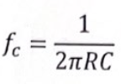

Where, fc = cut of frequency

R = resistor value

C = capacitance value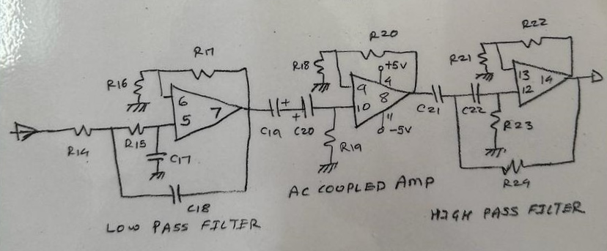

*Fig. 6.1 Low pass filter of 40 Hz and High pass filter of 1 Hz*

**iii) Regulator:**

The LM7805 regulates positive voltage while the LM7905 regulates negative voltage. Both ICs provide a stable output voltage despite fluctuations in input voltage and load variations. The "78" series regulators have a fixed output voltage, 5V for LM7805 and -5V for LM7905, making them suitable for powering various components in electronic devices.These regulators find applications in a wide range of electronic devices, including power supplies, amplifiers, and microcontroller systems, ensuring consistent and reliable power delivery.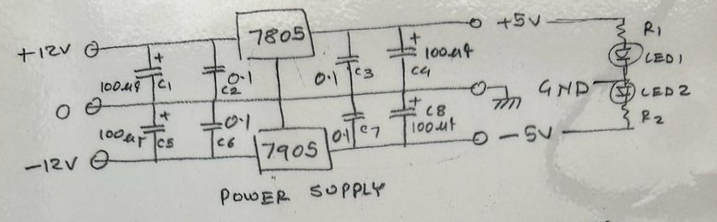

*Fig. 6.2 Power Supply for Circuit with Voltage Regulator*

**iv) Differential Amplifier:**

In EEG (electroencephalography), a differential amplifier is essential for accurately recording brain electrical activity. EEG signals are typically very low in amplitude and susceptible to interference from various sources, such as muscle activity and ambient electrical noise. A differential amplifier amplifies the voltage difference between two electrodes placed on the scalp, capturing the neural signals while rejecting common-mode noise. This enables the extraction of meaningful brainwave patterns, aiding in the diagnosis of neurological conditions, monitoring brain function during surgery, and conducting research into cognitive processes. Differential amplifiers in EEG systems play a pivotal role in ensuring high-quality and reliable recordings for clinical and research applications.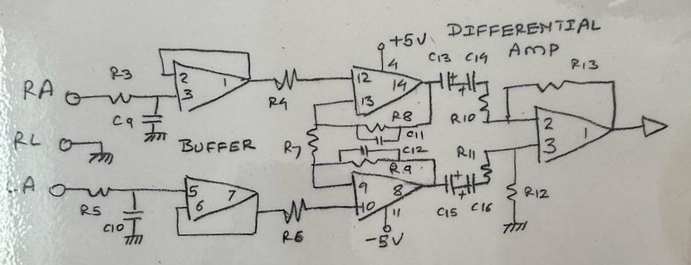

*Fig. 6.3 Differential Amplifier for Circuit*

**v) Operational Amplifier:**

Operational amplifiers (op-amps) are integral components in biosignal processing due to their versatility and precision. In biosignal applications like electrocardiography (ECG), electromyography (EMG), and electroencephalography (EEG), op-amps perform several functions. They amplify the weak biosignals to detectable levels, filter out unwanted noise and interference, and provide impedance matching between sensors and subsequent processing stages. Op-amps can also be configured for instrumentation amplifiers to enhance the signal-to-noise ratio and improve overall signal quality. Additionally, they facilitate signal conditioning, such as level shifting and offset adjustment, ensuring compatibility with downstream analog-to-digital converters (ADCs) or other processing units. Op-amps play a crucial role in achieving accurate and reliable biosignal acquisition and analysis in medical diagnostics and research.

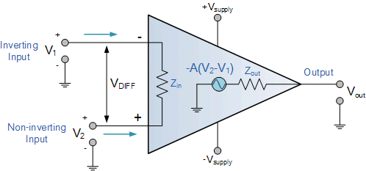

*Fig. 6.4 Operational Amplifier for Circuit*

**vi) Register Gain:**

"Register gain" typically refers to the ability to adjust or set the gain of a register within a system or device. In the context of biosignal processing or instrumentation amplifiers, register gain could refer to the capability to adjust the amplification factor of the amplifier by changing the values stored in certain registers. These registers might be part of the amplifier's configuration or control circuitry, allowing for the adjustment of gain settings digitally or through programming. For instance, in digital signal processing systems or microcontroller-based applications, the gain of an instrumentation amplifier or other signal conditioning circuitry can sometimes be controlled by writing specific values to registers within the device. This flexibility enables users to adjust the gain dynamically based on the requirements of the application or to compensate for varying signal amplitudes.

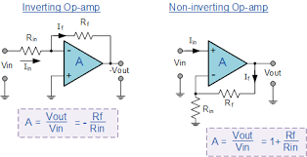

*Fig. 6.5 Gain Formula for the Circuit*

**Complete Circuit Simulation:**

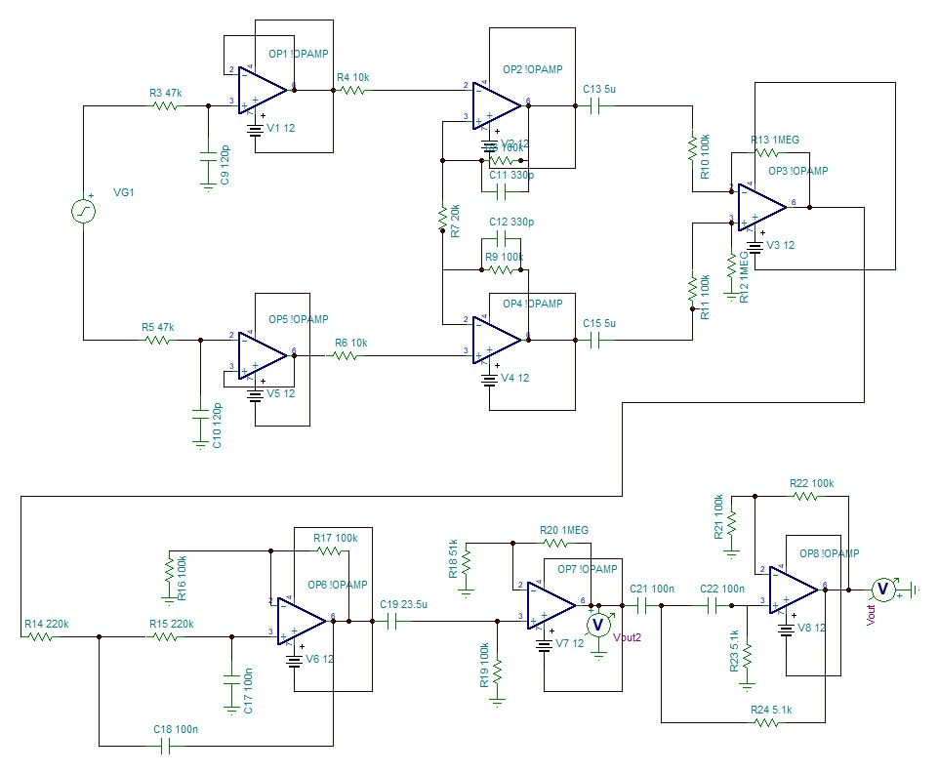

*Fig. 6.6 Complete Circuit for EEG of 40 Hz*

**CHAPTER 7**

**HARDWARE DESIGN**

**PCB Circuit:**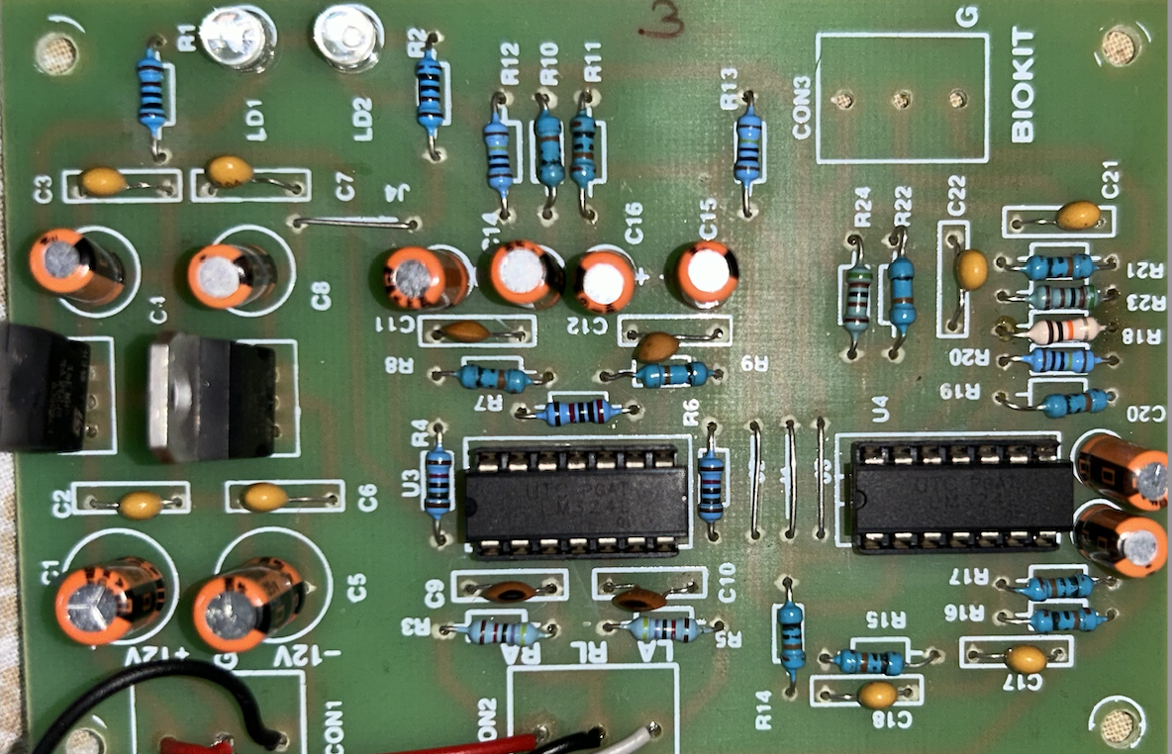

*Fig. 7.1 Designed PCB Board*

**Disposable Electrode:**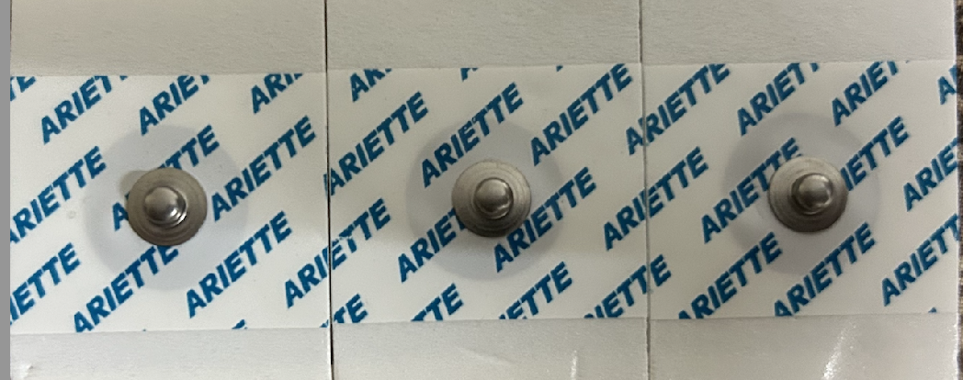

*Fig. 7.2 Disposable Electrodes*

**Output:**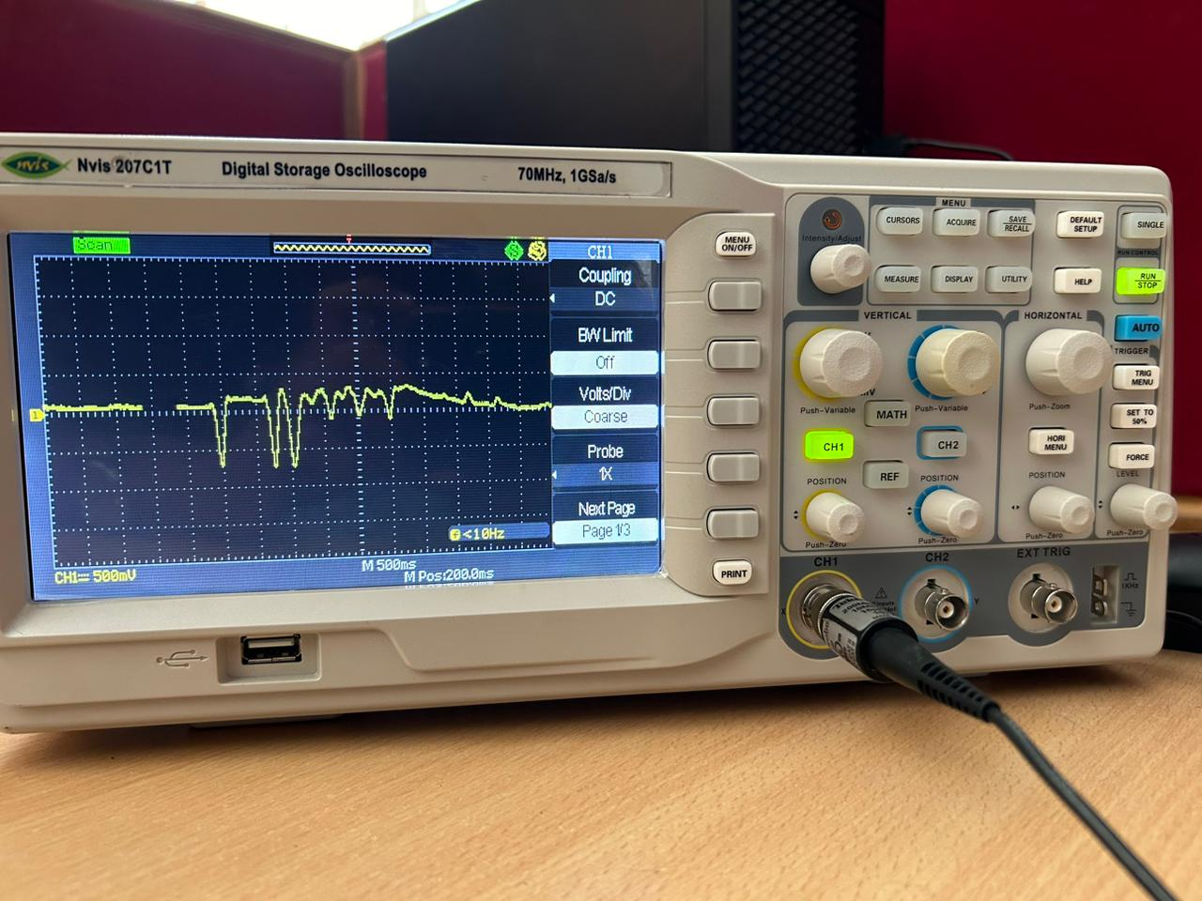

*Fig. 7.3 Oscilloscope Output of 10 Hz* 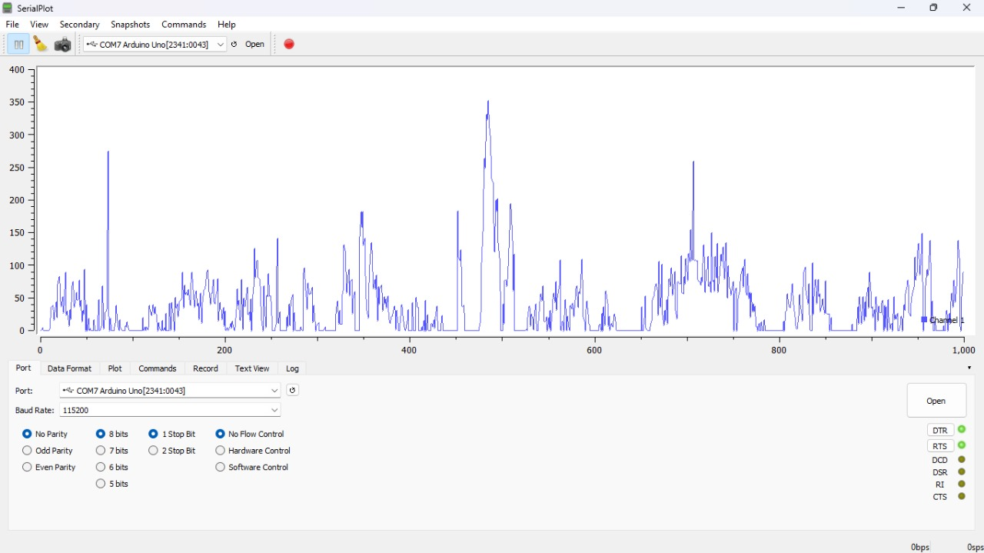

*Fig. 7.4 Output of 40 Hz using Arduino*

**CHAPTER 8**

**CONCLUSION AND FUTURE WORK**

In conclusion, silent speech recognition using EEG signals holds great promise in the field of assistive technology and human-computer interaction. By decoding the neural patterns associated with speech production, this technology has the potential to provide a means of communication for individuals with severe speech impairments or those in environments where vocal communication is not feasible. While there are still challenges to be overcome, such as improving the accuracy and speed of recognition, this emerging field continues to advance at a rapid pace. As researchers and engineers work together to refine the algorithms and develop user-friendly applications, silent speech recognition using EEG signals is poised to revolutionize how we communicate and interact with technology, opening up new opportunities for individuals with diverse communication needs. The future holds the promise of a more inclusive and accessible world through this groundbreaking technology.

Some notable future works that can be included in this project are:

Integrating a Raspberry Pi board along with a 24-bit ADC converter for improved accuracy and precise results.

Implementing additional noise elimination circuits and enhancing the PCB design to ensure optimal performance.

These advancements will contribute to further enhancing the functionality and reliability of silent speech recognition systems, making them even more effective tools for facilitating communication and interaction.

**Reference**

[1] S. Zhao and F. Rudzicz, "Classifying phonological categories in imagined and articulated speech,"*2015 IEEE International Conference on Acoustics, Speech and Signal Processing (ICASSP)*, South Brisbane, QLD, Australia, 2015, pp. 992-996, doi: 10.1109/ICASSP.2015.7178118.

[2] S. Datta and N. V. Boulgouris, "Recognition of Grammatical Class of Imagined Words from EEG Signals Using Convolutional Neural Network," Neurocomputing, vol. xxx, pp. 301-309, [2021]. DOI: 10.1016/j.neucom.2021.05.104

[3] M. A. Bakhshali, M. Khademi, A. Ebrahimi-Moghadam, and S. Moghimi, "EEG Signal Classification of Imagined Speech Based on Riemannian Distance of Correntropy Spectral Density," in Proceedings of the [Conference Name], [Location], [Year], pp. [Page Range].

[4] P. Saha, S. Fels and M. Abdul-Mageed, "Deep Learning the EEG Manifold for Phonological Categorization from Active Thoughts,"*ICASSP 2019 - 2019 IEEE International Conference on Acoustics, Speech and Signal Processing (ICASSP)*, Brighton, UK, 2019, pp. 2762-2766, doi: 10.1109/ICASSP.2019.8682330.

[5] Mohanchandra, K., Saha, S. A Communication Paradigm Using Subvocalized Speech: Translating Brain Signals into Speech. *Augment Hum Res***1**, 3 (2016).<https://doi.org/10.1007/s41133-016-0001-z>

[6] Sharon, Rini A. and Hema A. Murthy. “Correlation based Multi-phasal models for improved imagined speech EEG recognition.” Workshop on Speech, Music and Min, pp. 21-25, 2020. DOI:[10.21437/smm.2020-5](https://doi.org/10.21437/smm.2020-5)

[7] R. A. Sharon, S. S. Narayanan, M. Sur and A. H. Murthy, "Neural Speech Decoding During Audition, Imagination and Production," in *IEEE Access*, vol. 8, pp. 149714-149729, 2020, doi: 10.1109/ACCESS.2020.3016756.

[8] Rusnac, A.-L.; Grigore, O. Imaginary Speech Recognition Using a Convolutional Network with Long-Short Memory. *Appl. Sci.***2022**, *12*, 11873.<https://doi.org/10.3390/app122211873>

[9] Y. V. Varshney and A. Khan, "Imagined Speech Classification Using Six Phonetically Distributed Words," Front. Signal Process., Sec. Biomedical Signal Processing, vol. 2, Article 760643, 25 March 2022. doi: 10.3389/frsip.2022.760643

[10] S. Ling, A. C. H. Lee, B. C. Armstrong, and A. Nestor, "How are Visual Words Represented? Insights from EEG-based Visual Word Decoding, Feature Derivation, and Image Reconstruction," Human Brain Mapping, vol. 40, Iss. 17, pp. 5056-5068, DOI:https://doi.org/10.1002/hbm.24757.

[11] C. H. Nguyen, G. K. Karavas, and P. Artemiadis, "Inferring Imagined Speech Using EEG Signals: A New Approach Using Riemannian Manifold Features," Journal of Neural Engineering, 15 (2018) 016002, pp. 16 DOI:<https://doi.org/10.1088/1741-2552/aa8235>

[12] J. T. Panachakel, A. G. Ramakrishnan and T. V. Ananthapadmanabha, "Decoding Imagined Speech using Wavelet Features and Deep Neural Networks," 2019 IEEE 16th India Council International Conference (INDICON), Rajkot, India, 2019, pp. 1-4, doi: 10.1109/INDICON47234.2019.9028925.

[13] S. Mandala, K. Thakur, B. K. Singh, and H. Ram, "Decoding Imagined Speech using Wavelet Features and Deep Neural Networks," INTERNATIONAL JOURNAL OF CURRENT ENGINEERING AND SCIENTIFIC RESEARCH (IJCESR), ISSN (PRINT): 2393-8374, (ONLINE): 2394-0697, vol. 6, issue 1, 2019.

[14] L. C. Sarmiento, S. Villamizar, O. López, A. C. Collazos, J. Sarmiento, and J. Bacca Rodríguez, "Recognition of EEG Signals from Imagined Vowels Using Deep Learning Methods," Sensors, vol. 21, no. 19, Article 6503, 2021. doi: 10.3390/s21196503.

[15] A.-L. Rusnac and O. Grigore, "CNN Architectures and Feature Extraction Methods for EEG Imaginary Speech Recognition," Sensors, vol. 22, Article 4679, 2022. doi: 10.3390/s22134679.

**Timeline Chart:**

